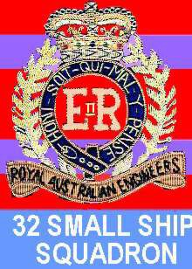The Forgotten Fleet 32 Small Ship Squadron

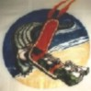32 Small Ship Squadron was formed in 1960 with four Landing Ship, Medium (LSM) purchased from the United States Navy in Japan. The four ships were ferried back to Australia by RAE (Tn) crews which also included Army Reserve personnel from various Reserve RAE (Tn) units. After modification to Australian Army requirements the LSM's began an 11 year career with the Australian Army. The LSM's were used in support of the Australian Army on the Australian coast, New Guinea, Borneo and one LSM was on station in Vietnam from 1966 to 1971 in support of Australian Army and U.S. Army units. A fourth ship, a 1500 ton Cargo ship, was purchased in 1965 and was employed as a "shuttle" service to New Guinea ports and to South Vietnam. All ships did sterling service for the Army. 32 Small Ship Squadron was disbanded in 1972 due to the economic life of the ships being reached. It was also decided that all "seagoing activities" of the Australian Defence Forces would be carried out by the Navy. In reality the only people who can support the Army, anywhere - anytime - wherever - whenever are the Army.

AV1356 | AV1354 | AV1353 | AV1355 | AS3051 | WW2
CLIVE STEELE | BRUDENELL WHITE | HARRY CHAUVEL | VERNON STURDEE | JOHN MONASH | HISTORY

105 Peter James Bayliss, 1992

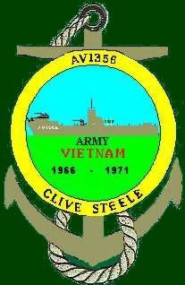

Returning from New Guinea in late 1965, Suzanne, who had returned earlier in the year was not impressed when I told her that I had been posted to 32 Small Ship Squadron. Since our marriage in Darwin we had a total of 42 months separation out of 57 due to Service reasons. She was hoping for a posting to Chowder Bay. I had about three months leave to take and during that period we, in partnership with her parents bought a four bedroom home at Carlingford which turned out to a place I stayed at on odd occasions for the next six years.

I took up my new posting at Woolwich in Sept 1965 and was surprised as the CO, Lt. Col. Wilson told me that I was to be detached to Chowder Bay as an Instructor until the end of the year.

Cpl David Briggs was to assist me and it worked well. We did what was required and every time I raised the subject by saying "What we are teaching is 'rubbish' did not go over too well.

I did enjoy the Instructional interlude as it allowed Suzanne and I to have the longest time together since we were married.

In Jan 66 I joined the "CLIVE STEELE" as Third Mate. This LSM was a 1000 ton Landing ship which was berthed at Nicol Bros. fitting out wharf at Balmain. My duties as well as taking the 12-4 Watch were as Firefighting and Damage Control Officer. The crew were being assembled and it contained quite a few National Servicemen who performed as well as, and in some cases, better than their ARA counterparts. The Master was Alan Webber, Lt. Deans as XO, Jim Fletcher as Second Mate and Phil Cannane as Second Engr. Trials were conducted and after the "hand over" we loaded cargo and departed for New Guinea going via Brisbane to Port Moresby, exiting the Barrier Reef at Grafton Passage (Cairns)

Unloading at Moresby was accomplished quickly as there was a load of Blue Metal to take to Daru. Because of discharge difficulties at Daru the Blue Metal was loaded into 44 Gal. drums with open tops, loaded using the ships' crane and being stowed with the Rough Terrain Forklift which was carried by the "STEELE". When we departed Moresby we had the sea and wind fine on the Port quarter. The metacentric height on an LSM is around 25 feet which makes for a very violent behaviour in anything above a moderate sea. If a load of some 200 tons is put aboard and the resultant load has a low centre of gravity the Metacentric height

reduces to between 12 - 20 inches and in that condition, as long as the GM is positive, the ship is no longer subject to violent rolling but now goes into a very slow roll with just a slight delay at its largest heel.

Apart from one crossing of the Papuan Gulf in the "FERN" in 1964, this was the best I ever had and it was now my 11th crossing. Arriving at Daru there was some problems with berthing at the wharf. The Daru wharf had a face of 70' and our length was 203' as well as strong SE wind. We ended up in an area near the shore where we should not have been and damaged the props. The unloading was time consuming as only one truck could be on the wharf at any one time and it had to clear the wharf causeway before the next one could enter. Daru had not changed at all and I doubted that a sealed airfield to take Mirage fighters would make a difference.

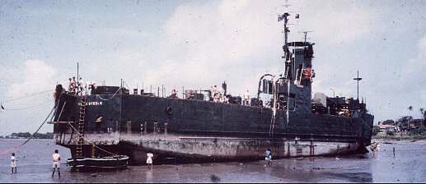The ship was beached close to the eastern side of the wharf causeway and repairs to the damaged props were carried out. On completion of repairs the "STEELE" returned to Moresby for another load of Blue Metal and then back to Daru. On return to Moresby we loaded cargo for Cape Killerton, Lae, M ad a n g , Wew a k an d
Vanimo. At Wewak we beached near the wreck of an ex- Army ship, AV2056 - a 250 ton Goal poster named "BUSAMA" but was originally the "EVELYN". It had a load of petroleum products and while unloading had exploded in 1955.

After departing Wewak we beached at Kairuru Island near the Mission and took on fresh water. While taking on water two members of the crew went for a walk with the ship due to depart at 2000 hrs. They had not returned by 1930 hrs. 1930 hrs. and a search party set out to find them. We first met a group of locals who had seen them earlier on a trail that led over the mountain to the North side of Kairuru and with some guides we set on the trail. It was pitch black and raining and the trail was a nightmare. After two hours of climbing we came to the peak and began the downward slide. The climb either was the most difficult we had ever seen or we were way out of condition - we were "stuffed"

A couple of minutes later I saw, on another hill, a line of torches that signified to me that it may be our lost crewmen. My excitement soon turned to embarrassment as it turned out to be a group of fireflies about 10 feet in front of my eyes. By the time we reached the beach on the North side we were utterly exhausted and simply sat down in the surf to cool off. There was no sign of the missing crewmen and the villagers nearby said they would begin searching at first light. Our problem was that we had to return over the mountain again. We arrived back on the ship about 0100 and slept very soundly until 0530 and went out again in the Dory this time to search. Two of us were dropped at a village on the Western side of the island and the dory began a search of the coastline to the North. None of the villagers had seen the missing crewmen and suggested we rest in the "Haus Kiap" which was a Sac-Sac roofed hut kept for visiting Patrol Officers of the TP & NG Administration. A short time later the dory returned and said that the two crewmen had been found a mile back towards the "STEELE". After returning to the ship we found that the missing duo had no idea where they had been or where they were going. The Skipper was not pleased. We sailed for Vanimo immediately.

After discharging at Vanimo we returned to Madang and then returned to Vanimo thence to Lae and then to Moresby for more runs to Daru. After completing the Daru runs we cleaned down the cargo deck and loaded return cargo. The night before we left the DTN and Ken Duncan came aboard. We learnt that the "STEELE" would be going to South Vietnam as soon as possible after returning to Sydney.

The "STEELE" arrived in Sydney at 0630 on a cold morning and after Customs clearance at Watsons Bay quietly berthed at Woolwich. Quiet Arrivals and Departures were a tradition of Water Transport/Small Ships and always reminded me of the "TARRA" - The destination Port did not want to know where you came from or where you were going, only how long you would be staying. The Departure Port did not have a clue where you were going, they only wanted to know when you would be leaving.

A few of the crew left the "STEELE" but as was usual in Small Ships, this meant going to one of the other ships and sailing on another "voyage from boredom to monotony calling at excitement, confusion and pride on the way". We discharged cargo that really should have been dumped at sea after leaving Moresby, which was, of course, accompanied by reams of documentation.

VIETNAM
A DIFFERENT GALAXY - A LONG WAY AWAY - AND A LONG TIME AGO

After a home stay of 12 days we loaded Plant equipment and about 15 tons of the AMPOL sponsored “SCIENCE for High School Students” text books. These books were of two volume sets and were translated into Vietnamese. We then sailed for South Vietnam. The route was up Grafton Passage thence to Manus for refuelling and thence to Vung Tau.

We passed the Southern tip of Mindanao and then across the Sulu Sea to Balabac Strait and entered the South China sea. About 200 miles from Vung Tau we were intercepted by a US Navy Neptune Recce. Aircraft and about six hours later we were again intercepted, this time by a Destroyer of the US 7th Fleet. After exchanging the usual courtesy we proceeded to Vung Tau arriving late at night. There were quite a large number of ships at anchor off Vung Tau and it was not until the next morning that we realised just how many there were.

There were some 30 Merchant ships at anchor waiting for clearance to go upriver to Saigon. The majority of these ships were Liberty and Victory ships that had been bought out of "Mothballs" for the Vietnam War just as they had been "De- mothballed" for the Korean War. We proceeded to the Beaching area which was controlled by the US Army but actually operated by a Contractor - Alaska Barge & Transport. We remained here until the following day and then went upriver to Saigon. The river was heavily patrolled by the US Navy and on the way upriver it was normal to see three separate groups (two to a group) of PBR patrol boats. These boats were only 24 feet long equipped with Radar and heavily armed. They were of fibreglass construction and had two GM engines driving water jets and had a speed of 25 knots During daylight hours these boats were on the move at all times and intercepted every Vietnamese craft they encountered. There was a river curfew from 1800 to 0600 and the PBR
's during this period lay on the river with engines stopped, Radar on and drifted with the current. If anything moved on the river they fired at it. There were also three groups of 60' Minesweepers continually sweeping, one to each side. If Tankers were on the river then there would also be Helicopter Gunships on patrol above.

The river was Lifeline to the US build-up and it was a game VC who would take the patrols on. The VC did take up the challenge and it was simply a matter of odds. The river to Saigon was 48 miles in length which meant 96 miles of riverbank. The whole length of the river could not be watched completely and simultaneously and there would be gaps in the patrolling. The VC slipped into these gaps, Sometimes one man - sometimes two, and waited maybe an hour or maybe two days until the right target came along. After 1967 the VC activity decreased but even then it was not unusual for a rocket attack on a ship to take place. We arrived at Nha Be, on the outskirts of Saigon about 1600. This was the Saigon Fuel complex and even here the VC made their presence felt. There was a Panamanian ship fully loaded, on the bottom with its superstructure above the water. An expertly placed mine had done the job.

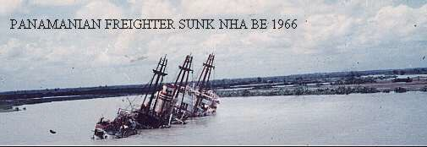

As we moved into the port of Saigon it was nothing less than a chaotic mess both on the river and on the wharves. Ships were being unloaded alongside wharves and in the stream. Normal Vietnamese shipping was
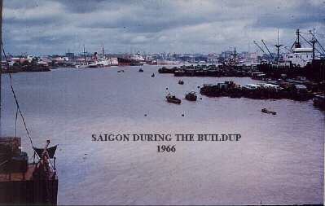relegated to the far
Southern end of the Port and here one saw just about any type of vessel flying any
flag and in any condition. It was in this bunch of
shipping some weeks later that we saw a 300 tonner flying a Singapore

Flag, It was good to see of our ships still plying around SE Asia.
one

We berthed at the
Vietnamese Navy ramp in the Navy Yard and to meet us was "Skinny" Truslove, Movements WO at HQ AFV. Unloading was undertaken by Vietnamese and as we were carrying some Plant equipment as "Aid to South Vietnam from the Australian people", there were Aust. Embassy people present. The first thing that was removed from the Plant equipment was the small brass plaque fixed to each, item which stated that it was a gift from the Australian people. I asked one of the Embassy people what was going to happen to the Equipment and he replied "I don't know - probably go to the black market" and I asked if the books would be used and he replied "I doubt if they would even be used as toilet paper". There was neither Public relations presence nor official handover ceremony - just equipment and books being dragged off the ship while Australian Embassy staff stood there with bored looks on their faces

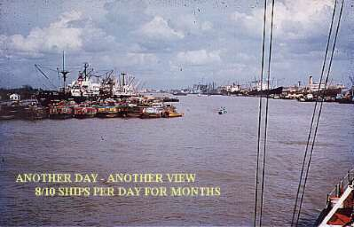Since I was not on the Duty Watch I went with "Skinny" to a restaurant, the "DON KANH" in Cholon for a very good meal and then to the BOQ where he was staying. We h ad a f ew beers and as it was past Curfew I slept on the floor of his room. His roommate was a US Army Captain and being new to Vietnam I wanted to know what was going on.

The Captain worked at HQ US Military Assistance Command, Vietnam (MACV) and was rather forthright about Vietnam. He said that every time the VC or North Vietnamese Army would "come out to do battle, he would be beaten" but sooner or later South Vietnam would go Communist. I thought this was a little defeatist and asked why he felt that way. He said that although we were fighting Communism which was the name of the game, we were also up against a problem of the South Vietnamese using us to further their own ends. He also said we were engaged in a war that was being controlled by politics and at times one hand had to be tied behind our backs and at others both hands were tied. He said that "even if the US Military was let loose to prosecute the war as a war, we would win very quickly - but what then? - they would start again the day, after we packed up and went home to glorious victory parades!”

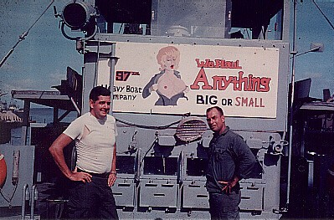I was somewhat disturbed by this but I remembered his words some three years later when I served with the US Army in the Mekong Delta and I was issued with a little leaflet called the "Rules of Engagement" every time we went on mission. You could return fire in some areas only between certain hours, You could return fire only to one side of t he ri v e r in c e r ta in areas and in some cases you had to get permission to return
fire from a higher authority and of course there were "Free fire areas" where if you weren't sure then shoot it. The problem with "Free fire areas" were that "friendly" troops ashore also were in the "Free fire" zone particularly the South Vietnamese and they rarely knew if we were on the river.

We did a few trips from Vung Tau to the Baria Ramp for the Australian Task Force, which, in retrospect seemed rather silly as the Australian Logistics group at Vung Tau ran daily truck convoys to Nui Dat (1st Australian Task Force). We also carried loaded trucks which formed a convoy when unloaded. It may have seemed silly but if the road was cut then we would have been the means of transport. The river, of course would have been easier to cut than the road. The trip to Baria Ramp was only about two hours but the final turn to the Ramp was very tight as the photo suggests.

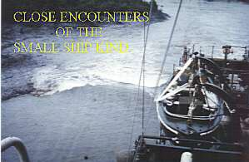In August we had departed Saigon for Vung Tau and were halfway down the river when the was a flourish of Air activity and Helicopter gunships made their way down to a place called "Le Quatre Bras" which was a multiple junction in the river. Earlier that morning a fully loaded Victory ship, the "Baton Rouge Victory" was coming up river to Saigon when a mine exploded under the Engine room. The Engine room staff were killed and the Captain ran the ship to the bank and she settled on the bottom parallel to

the bank. As we went past there were already US troops on both sides of the river digging in and aircraft and choppers were searching the hinterland. Later we found out that the method used was standard. The VC had come in probably 2 days before and dug a little "hootch" into the bank. They would have had a four gallon drum packed with explosive, tyre tube, length of rope, rocks or metal counterweights, detonator wires and a battery.

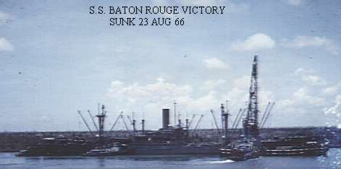They would have been after a Victory ship and it was only a matter of setting up the mine in the centre of the river at night weighted at the bottom and held in place by a pulley which the operator could then raise or lower the mine which was supported by the rubber tube. When the loaded Victory ship, which would be in the centre of the river, came by - the VC would join wires and the mine would explode. To counter the minesweepers the VC, from his little "hootch", w oul d p ull on h is
rope and the mine would go to the bottom and the sweep would pass overhead. in this particular case he was very successful as there was a secondary explosion as a boiler exploded. The "Baton Rouge Victory” carried general mixed Military cargo and w as car r y i n g b us e s as deck cargo.

The next time we came through the new buses were dumped onto the bank and they were unloading the cargo. The defensive perimeter was still in place as they were not sure if an attack would be mounted to get some of the cargo although I could not see any sense in that as they would not get within 500 metres of the ship. due to the open and marshy ground. They just wanted to let the Allies know that they could sink shipping anywhere and at any time - after all they had been doing it since the 1930's.

We passed the "Baton Rouge Victory" quite a few times and they had unloaded her but could not get an effective covering over the holes that were blown into the side as a result of the secondary explosion so they sealed off the engineroom and towed her to Vung Tau to effect further repairs necessary before moving her to the Philippines. Nothing they would do would hold and the end result was that she was taken out to sea and, I believe, used as a target, sunk.

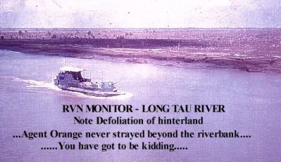In view of the controversy surrounding "AGENT ORANGE" it is necessary to relate our experience with defoliating agents. At the time we knew nothing of Agent 245T but on three occasions the "CLIVE STEELE" was sprayed with Defoliants. The Saigon River (Rung Sat Special Zone) was the lifeline for not only Saigon but also for the USAF b as e at Bien Hoa.

Defoliants were introduced into Vietnam in 1961/2 as a means of destroying crops thus denying the VC of a food chain. I never saw any of the areas where crops were destroyed.

In the mid 60's the defoliants were perfected and were generally known as Agents Orange, Blue and White. Agent Orange was a combination of the herbicides 245T and 24D, Agent Blue was Cacodylic acid and Agent White was a mixture of 24D and Picloram. At this time the Commander of US Naval forces, Vietnam, Vice Admiral Elmo Zumwalt, decided to spray the riverbanks of the Saigon River and the rivers in the Delta where shipping was of paramount importance. The reason for this was that casualties of personnel aboard Patrol craft were in the order of 5-6% and large ships were being hit. We were sprayed either early in the morning or late afternoon (the reason for this, I found out in 1969 while serving with the US Army, was that in the heat of the day the Agents used would not stick to the leaves).

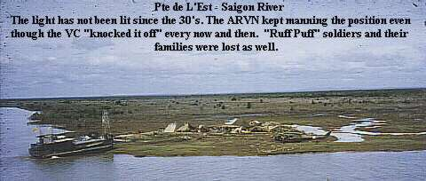

We were never warned of the spraying and the first indication was a C-123 on either side of the river would appear from astern with spray coming from the wings. I do not think that they intended to spray the river but it was sprayed over us anyway mainly by wind. All of our gun crews received the spray and this was not the residual spray but direct and we who were on the Bridge received the spray even though we had overhead cover.

The mist which covered us was a fine oily substance and aboard ship we did not wear sleeves rolled down nor did we wear headress unless Action Stations were sounded. Anyone who was on deck also received the spray directly. Had we have been advised of the spray I have no doubt that precautions would have been taken but then we are all guilty of not having "forward hindsight".

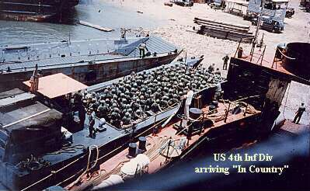On one of the runs between Saigon and Vung Tau we carried quite a few drums of defoliant and memories of this cargo was that many of the drums were leaking. When we arrived in Vung Tau the cargo was removed that night by the AB & T Stevedores and the next morning the deck crew had "quite a time" removing the sticky mess from the cargo deck. I have had no contact with anyone from Small Ships since leaving the Army so do not know if the spraying has affected anybody and it is mentioned here as a record just in case something happens to me.

On one occasion we came off the Ramp at Vung Tau and went too far astern and damaged our props on the Island astern of us and spent a week in the Dry-dock at Saigon. On another occasion we were to berth alongside a Korean LSM at Saigon and unfortunately we hit him amidships, backed off and went in again. By this time the Korean Skipper was on his Bridge and as our Skipper was yelling to Jim Fletcher, on the Bow, to get the lines onto the Korean LSM the Korean Skipper was creating just as much bedlam by telling his crew not to take our lines.

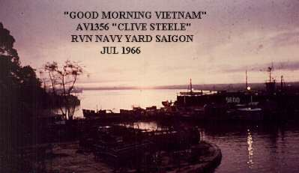The wharf situation in Saigon, for the Merchant ships, was becoming very chaotic. The US Forces controlled the best wharves which were called MM1 through MM6. The total length of the MM series could take
eight ships and no sooner had one departed than another was into its space. The same applied to the Stream anchorage where there would be another four ships - Bow to stern. The cargo unloaded from the ships in the stream was loaded onto Vietnamese lighters. These lighters were operated by a whole family who were born, lived and died aboard.

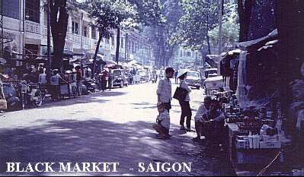It was not surprising that after loading that a complete or partial load would go missing and sooner or later turned up on the two Black market streets that were openly trading in downtown Saigon. On the wharves the unloaded cargo could not be cleared from the wharf quicker than it was being
unloaded from the ships and consequently the area behind the wharf became a mountain of cargo and amongst all of this it was not unusual to see an aircraft wing, the rest of it covered by other cargo: One of the more interesting ships to come into Saigon were the Seatrain vessels. I as s u m ed that these vessels would load freight cars in San Diego and rolled off in Saigon but they
mainly carried vehicles. The VC had destroyed so much line and caused so many casualties that the line to Danang was closed and the trains did not leave Saigon.

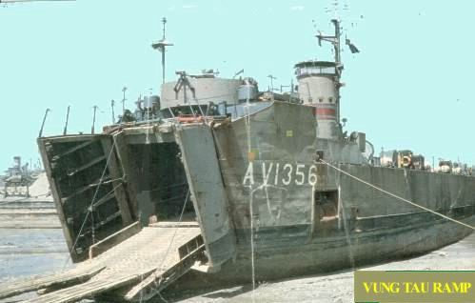

One insight into the war occurred when we pulled into the Tank Farm at Nha Be to refuel. It was about I700 and as refuelling took place we had a look around the place and ended up talking to the Manager of the Shell complex. in the course of talking we asked if the place had ever been hit to which the reply was "No" and somebody asked the inevitable "Why". I don't know if he was telling the truth or not but he said that “tax" was paid to the VC. This "tax" was then added to the contract price to the US Forces.

Nha Be was a very large complex and it not only serviced the civil requirements of Saigon but also supplied the Air base at Ton Son Nhut and the Bien Hoa Air Base. If you extend that further then it would appear that we were subsidising the VC so that our aircraft could then have the right to bomb the daylights out of them.

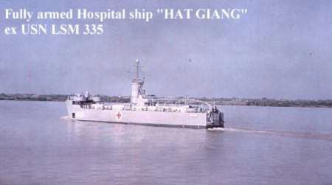

We stayed overnight here and during the night to the South there were massive attacks from the air by two "Spooky" C-47's these aircraft were equipped with four miniguns each firing
6000 rounds per minute. A "Puff the Magic Dragon" C-47 would circle high above an area, to which it had been called, and remained until it was told to "illuminate" after which it dropped a succession of very high Candlepower parachute flares. the "Spooky" C-47's would then be given a reference point and the pilot would then aim the guns, by looking over his left shoulder.

The guns were mounted on the port side of the aircraft and the pilot would go into a turn pressing the fire button at the same time. The rounds were 7.62mm and one in five were red tracer. Four continuous arms of red would come down from the aircraft and obliterate anything, no matter what it was, on the ground under it. They guaranteed to break up any attack. The claim was that they could put a bullet every 9 inches in a football field in 10 seconds. I saw "Spooky" and "Puff" many times playing their game but it was not until Nov
69 that I saw the results on the Mekong River near the Cambodian border that I began to realise the firepower that these aircraft put out.

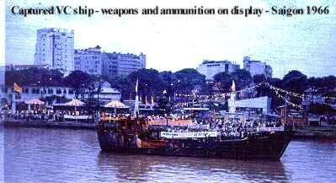One night a few of us went ashore and had a meal in Cholon and went up on the roof where a bar was set up and one could relax without the smell or noise from below and watch the war. Saigon was surrounded and the VC owned the outer hinterland by night. The war was going well as the news broadcast told us, I was to see this same phenomenon from a different hot e l in 196 8 an d ag ai n from the rooftop of the REX BOQ in
downtown Saigon in 1970, The "Light may be seen at the end of the tunnel" but the VC were having fun turning the lights off every now and then.

We expected to take the "CLIVE STEELE" back to Australia but the plan was changed and a relief crew was flown in "dribs and drabs" to Saigon and we left the same way piecemeal. We had been continuous for 11 months and now it meant a break which meant we would go to another ship after we got home. On the day I left Vietnam I tore a ligament at the base of my spine when picking up my luggage to load onto a Caribou which was to take a few of us to Saigon.

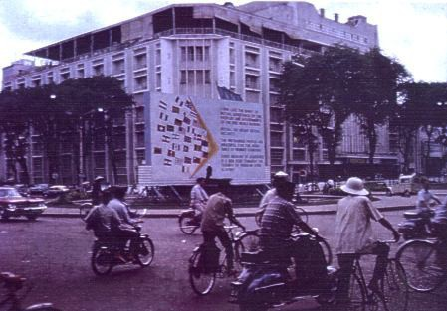
The "Flags"- a common meeting place when in Saigon, Rex BOQ in background

At Saigon five of us were booked onto a Pan American 707 to take us to Manila where we would pick up a QANTAS 707 from Tokyo heading to Sydney. I was booked First Class and

on entering the aircraft was surprised to find that the First Class section had only three seats occupied. One of the two other passengers was an American General so I sat in my seat and tried to look as inconspicuous as possible. We had to wait for about 15 minutes at the end of the taxi way as Fighter and Fighter Bomber aircraft had precedence.

While we were waiting the General came over to me and introduced himself. He was Lt. Gen. Jonathan Seamann, Commander of the US forces in the III Corps area of SVN. After the usual introductory chit chat I asked the General if he was "going finish". He replied that he was going to Washington to appear before a Congressional Committee on Vietnam. During the conversation I asked as to what goes on at these "hearings". He simply replied "It is similar to a balancing act on a highwire - give the wrong answer and one will lose balance and fall heavily and give the truthful answer and one can also fall heavily". I remembered the words of "Skinny" Truslove's roommate. We had lunch together and the conversation went from the Army to Home, wives and families

By the time the aircraft landed at Manila my back felt like a furnace. We were booked into the "International" Hotel in Manila and I asked the reception people could I have a Massage in my room. Three girls duly appeared and I must have put my request for a massage in the wrong context as these girls were not there to give me the massage that I had in mind. After a hurried telephone call to the main desk the matter was sorted out and it appeared that the hotel did not have the capability to provide the massage I wanted but the girls could be provided at any time.

We departed on QANTAS a little after midnight and I was in First Class again, sitting next to a lady who had obviously done a lot of shopping in Tokyo. She appeared to be rather peeved that someone was sitting in the seat where all of her purchases were placed. The pain in my lower back was becoming unbearable and the lady next to me seemed to resent my presence. Maybe "Vietnam" was already a dirty word in Australia. I could not have cared less about her or anyone else by this time and asked the Stewardess could she bring me a few straight Whiskies and I then slept until Sydney.

Suzanne met me at Mascot and when I told her about my back, which was now very noticeable as I could not stand straight and the upper part of my body was off to one side, She became rather pleased as it would probably ground me to a shore posting. I went out to Watsons Bay to see the Medics the following day and after deciding that something was wrong (The doctor was one well known to everybody in the Army - I think he had been a consultant at the signing on of soldiers who went to the Boer War), I was given a Cortisone injection and was made "Home only" which was not exactly what I wanted. Three weeks later I was formally put back to DP1. This did not please Suzanne. The only thing that I regret about that medical examination was that no X-Rays were taken.

Before going to Vietnam on the "STEELE" I had been advised to read some books on Vietnam and did not get around to reading them so while on leave I bought the four books and read them. The books were.

• “The Making of a Quagmire” by David Halberstam (1963)

• “The Street without Joy” by Bernard Fall (1954)

• “Peoples War, People’s Army” by Gen. Giap (NVA) and

• “The Protracted War” by Gen. Giap or Ho Chi Min

The last two books I bought from the "Russian Bookstore" for a price that I cannot remember but certainly a lot cheaper than the first two. I read those books and the first book I thought was a little defeatist". Years Later I discovered that Halberstam was not "Defeatist" but had hit the nail right on the head, the second which was disturbing. I was not really familiar with "Communist Strategy" in relation to the last two books but none the less I found them interesting and believed that the books had been read digested and countered by the US Command. When I came home from Vietnam the third time in 1970, I was to remember those books and read them again.

1967-AV1354 "BRUDENELL WHITE" NEW GUINEA

In Jan 67 I joined AV1354"BRUDENELL WHITE" with John Hartnack as Master and Doug Iffla as Second Mate, myself as Third mate. We loaded and it was back onto the New Guinea run. This run was now becoming a scheduled service. Very soon we would be running to a published timetable. The ship did not have the tension of the "CLIVE STEELE" due to the different personalities of the Skippers but the ship itself was not as good as the "CLIVE STEELE". I was quite happy working with Doug and the crew were very good and, as we travelled from boredom to monotony and back I began to think, in the Water Tpt/Small Ships context, where did I come from Where was I and where was I going?

We had become very large overnight, from a small but cost effective unit and I was now part of a machine that spelt" Think big - Think Small Ships - The way to go". I could not see a future in moving from one ship to another. Vietnam would not last forever and TP & NG would gain independence sooner or later and when that all happened would the "Big Ship" philosophy survive? If it did not then I could see the return of the ALC-50 type craft gaining prominence in Long range Support of the Army. (Being so far down the list it was my right to think of such things, as was the right of my superiors to not listen to what I was saying).

In retrospect I was wrong on all counts. There was no career pattern for us as we would not fit in to anything outside this environment. Within the Small Ship environment, there was Movements and a new branch loosely called Terminal Operations, neither of which appealed to me. My forward thinking came to a stop in Madang when a signal was received saying my eldest daughter, Karen, was seriously ill in Eastwood Hospital and Lt. Col. Wilson ordered my return to Sydney. I left the ship wearing my "normal" civil attire, shirt, shorts and shoes (socks rolled down) and an airline overnight bag. Staying the night with the Manager of Madang Slipway who was a friend from "taim bipor". I was on a plane the next morning and in Sydney at 1630 that same day. How different from 1955 when it was 12 hours by QANTAS DC-4 from Moresby to Sydney. To have travelled from Madang to Sydney in those days would have been two days.

A car was at Sydney to take me to Carlingford and on the way we stopped at a set of pedestrian lights at Campsie. The Traffic lights were on top of the Station and as it was peak hour there were hordes of people crossing. As we waited I looked at the people and all had the same look. They were all looking down but nobody collided with those in front. Not being disrespectful, the scene reminded me of cattle going to their inevitable fate. At least one of my questions was answered - I was not going to become part of the Sydney scene. I still had rather a large amount of residual leave left and spent a few days at the hospital until Karen was off the critical list. On reporting at Woolwich Lt. Col. Wilson told me that I would not be returning to the "BRUDENELL WHITE" but I was to be detached to Chowder Bay again as an Instructor.

The W01 Instructor at Chowder Bay was Len Fitzgerald with whom I had crossed swords many times in 1954 when Len, as a S/Sgt, had been Barrack Master at Chowder Bay. Len had been with Movements as an Instructor and had crossed over to Maritime operations and the LSM's. I thought that this was not going to be a very happy detachment but I was wrong as we got on very well together, except he did tell me to forget about slipping into the instruction that I thought should be taught and stick to the Syllabus. On that note I began to teach Seamanship and Coastal navigation as well as Celestial Navigation.

I was still a temporary W02 and in fact had not attended any promotion courses since 1958. People who had joined long after I did and were Sgts. were senior than I was on the promotion ladder and some were W02's. I was certainly getting more experience and knowledge but was lagging way behind in the fields that counted in the promotion context, namely Tactics and Administration. I did apply for a Commission and was surprised when I was required to attend a selection board at Watsons Bay. There were some 35 applicants and we were split into groups and group discussions were held.

After a few weeks and several more interviews I received a letter saying that I had been selected to attend an Officer Training Course at the Jungle Warfare School at Canungra. Out of the 35 applicants only six were selected. I was apprehensive about attending as the Course, apart from being very physical and mentally exhausting, did centre around Tactics and Administration and I was very weak in those subjects. Depending on when the course would start I would have to learn quite a lot and fast! I never got the chance as two weeks later the course detail came through and I was starting two weeks hence. I was floored by this but I had nothing to lose and I would give it my best shot. The Course was very demanding as stated and I could handle the physical side - daily five mile run at 0600, through the Assault course three times weekly and rope work suspended between trees.

The mental pressure kept on increasing and it was applied, I think, to determine the break point. One did and was removed immediately. One of the tactical situations had me as a patrol leader and during the "patrol" we would come up against a set of situations and one of the situations was finding a "wounded VC" with a fake stomach wound begging for a glass of water. I had put a rope put around his leg and then from a safe distance dragged him away a few feet just in case he had some "funnies" planted under him. I then decided to cut his throat and as I approached the unfortunate Infantryman who was playing the part, one of the Directing Staff, a Major, jumped out of the bush and yelled "What the bloody hell do you think you are doing ?" and I replied I'm going to cut his throat, Sir". He replied "You murderous Bastard, haven't you heard of the Geneva Convention" and scribed a big "X" across his pad which was my sheet.

We were then told to get into the bush and shut our mouths as the next party was due. When the next student arrived he took the opposite view to me. He dragged the "VC" as I did and then took him off the trail and gave him a drink of water and then prepared to go on. At this point the Major jumped out and demanded to know why the "VC" was being left alive. The student replied that the "VC" had a stomach wound and the water would probably kill him anyway. The Major blew his stack and said that you do not leave an enemy after he has seen you. Either take him prisoner which you cannot or kill him. He then said "wrong" and drew a big "X" across his sheet. There was no answer to the problem - they just wanted to see if you could make a decision.

I did not do very well in either the tactical or Administration aspects of the course and did not qualify but to this day that course was the best Army course that I ever attended. I came away from it very fit but more importantly, I learnt more about Tactics and Administration that if I

were to have started another course I would have qualified. Going back to 32 Small Ship Squadron without a Commission was no disgrace but Suzanne was as disappointed as I was, but only momentarily. In early 1968 it was decided to hold me back from going to another ship and send me on the various courses at SME and elsewhere in order to confirm my rank. These Courses were a breeze after Canungra.

1968 - AV 1356 "CLIVE STEELE" - VIETNAM

In May 1968 I rejoined the "CLIVE STEELE" in Vietnam as Second Mate. Wally Blumenfeldt was Skipper and Les Dennis was Third Mate. The XO was a CMF fellow from Brisbane. We began working with primarily US cargoes and our ports of call were Phan Rang, Cam Ranh Bay, Qui Nhon, Nha Trang and Danang as well as Dong Tam and Bin Thuy in the Mekong Delta. Cargoes carried varied from general cargo to Self Propelled guns and Tanks.

Since 1966 the Port of Saigon had become rather orderly, mainly as a result of building another Port about 3 miles upriver from the main port. It was called Newport and it was from here that our cargoes were loaded/unloaded. There was still a lot of VC activity across the river resulting from the TET Offensive and there was a US artillery Battery in the middle of Newport continually firing away. Life in Saigon was still the same. We watched the war again from the bar atop hotels and the place was still surrounded by VC. Some of the more memorable incidents were.

DANANG

Danang was some 400 miles North of Saigon and we carried a full load of M-109 155mm Self Propelled guns from Saigon. Our first stop was the beach at Phan Rang where the USAF had a large Airbase a few miles from the beach. The cargo we had for Phan Rang was a small amount and was for 1 Squadron RAAF which was operating out of Phan Rang with "Canberra" Bombers. We were only staying on the beach for a couple of hours which was just as well. the "beach" consisted of a hulk run onto the beach, cut down to a reasonable height above high water , filled with concrete then an approach was put in and a wharf was now available to offload the dumb barges which usually maintained Phan Rang although LST's were frequently using the "beach" to offload equipment and munitions. We beached alongside the "wharf" and on the other side was the remains of a dumb barge that was carrying a load of Napalm and had been hit by a VC rocket attack. The sight of the mangled mess made our stay as short as possible.

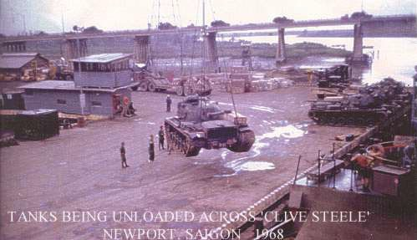

We then proceeded to Nha Trang and beached for a few hours before departing for Danang. The outer harbour at Danang was full of Transports and we had to wait a day for the USN LST Ramp to become available. We unloaded the Guns and were host to a few Australians who were Advisers to the South Vietnamese Army. They were the only Australians serving this far North.

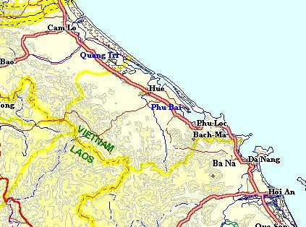

I had occasion while we were in Danang to visit the US Naval Support Facility which was to the NE of Danang. The scene here was one of continual loading and unloading, repair of Landing Craft, the sorting of battle damaged tanks/equipment etc. prior to loading for Okinawa where it would be refurbished and come back to Vietnam as new as it ever could be. There was also an advanced hospital as well the area was generally known as "China Beach".

I also visited the Danang Airbase which at the time of my visit would have had in excess of two hundred aircraft within its perimeter. There were charter 707's coming in from the States with reinforcements and while they were landing there were 707's waiting to take off for the States each with 180 very happy servicemen aboard. All of these aircraft gave way to the continual wave after wave of combat aircraft landing and taking off interspersed with a multitude of helicopters going to and fro in every direction.

Our next Port after departing Danang was Qui Nhon. This was once a small town that may have been able to support a population of 20000 or so but it was now nothing more than a filthy hovel. Not only was it crammed with US , South Vietnamese and Korean troops it was also the focal point for refugees from the hinterland and the Highlands. The streets were nothing more than garbage and mud. There were several POW cages and inside the cages was a lot healthier than outside. We went to the local PX and it was the same as elsewhere in Vietnam. One could buy the very latest Stereo Tape Recorder for US$200 but it was impossible to buy toothpaste, soap or a tin of Coffee. They were available on the Black- market two streets away at ridiculous prices.

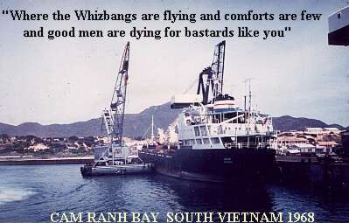We returned to Saigon for another load of Cargo and while in Saigon a signal was received that we were to proceed to Cam Ranh Bay to off load tanks from the "JEPARIT". We were to pick up a team of Armoured Corps people at Vung Tau and depart for Cam Ranh Bay. It appeared that our wonderful Australian Merchant Seamen were playing their silly little games again. The
"JEPARIT" was carrying four Centurion Tanks destined for the Armoured Squadron at Nui Dat and on arriving at Vung Tau there was no Crane to offload them. The US Army had two floating Cranes at Saigon and if the "JEPARIT" was to go upriver to Saigon they would be unloaded and could then be loaded onto US Army LCU's and taken down to Baria. Since the Saigon River was a dangerous area the seamen quoted the "signing on articles" which precluded "dangerous areas" but, as we were told, would reconsider if massive "danger money" was paid.

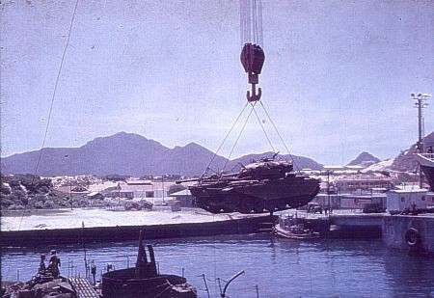

Consequently the ship was re- routed to Cam Ranh Bay where the US Army had a 150 ton Floating Crane and we would load the tanks and take them to Baria. We had a quantity of Corrugated Iron as cargo for Cam Ranh so we departed Saigon in a hurry. On arriving at Cam Ranh Bay we found the "JEPARIT" already alongside one De Long Pier and we berthed alongside another. At no time during the time we spent there did we see any of the gallant Seamen aboard the "JEPARIT". While unloading the Corrugated Iron the US Army Mobile Crane was a little too confident in picking up the Corrugated Iron, as after all it did not look heavy and as a result the Crane toppled into our Tank deck. Luckily nobody was hurt.

We then moved around to the beach to receive the Centurions and that proved to be a disaster. The Centurions were placed on the wharf by the floating Crane and were to be driven to the

Front Beach and loaded onto the "CLIVE STEELE". They had a hard job starting them and some had to be towed around to Front Beach The Armour people were not happy and we never did find out if those tanks had been interfered with. After we finally loaded them aboard we moored alongside a small "T" wharf on Front Beach. The surge here was very heavy and the ship rolled all the time. Unless duty required us to be aboard most of us sat on the wharf and watched the "STEELE" perform. The Bridge Inclinometer registered up to 22* rolls. At sea it was nothing but alongside was ludicrous. After I left the Army I was told that the only reason an LSM was on station in South Vietnam was that if there was any "industrial trouble" with the crew of any Australian merchant ship with cargo for the Task Force then we would unload the ship. What a helluva way to fight a war. Later the "Jeparit" was taken over by the Navy and commissioned as a HMAS. We left Cam Ranh later that night and went direct to Baria to offload the tanks.

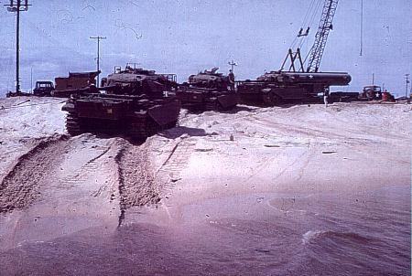

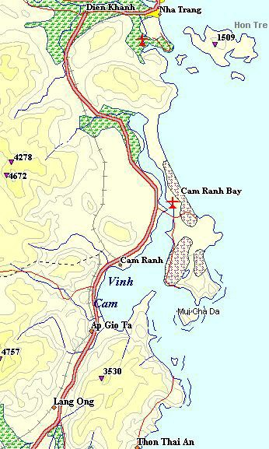

BIN THUY

Bin Thuy is situated on the Bassac River and is really part of the Mekong but the Mekong splits into two just inside the Cambodian Border. We did quite a few runs between Saigon/Vung Tau - Bin Thuy. We always carried US cargo on this run as, apart from four Advisers from the Training Team, there were no Australians serving in IV Corps (Mekong Delta). The run was usually an afternoon departure from Saigon with an arrival time at the River mouth just after daylight the next morning. it was then about six hours upriver to the Ramp. The main US base was about three miles from the Ramp and consisted of the US Army Airbase and a CasEvac Hospital with Support units. The South Vietnamese Army had its own base.

The main function of the US Army aviation units was Electronic Surveillance. The Airbase was also serviced by USAF Hercules and Caribou Aircraft and was a very busy area. The VC (according to the Communiqué released by the "5 o'clock Follies") had been hurt so severely that he was no longer in control of the Delta. Unfortunately the VC, in the main, could not read English and did not listen to the news.

We frequently carried Cargo to Bin Thuy and as the beaching area there was rather small, LST's and LSM's tended to beach in the middle, but usually only one vessel would be on the beach at one time. On one occasion we arrived when there was a USN LST beached and the only room for us was on her Starboard side. The Bassac current pushed us onto the LST causing some damage to the Bridge area. Apologies were made and accepted. We had passed this particular LST a few weeks before at the mouth of the Mekong River, aground and wrapped around a string of Vietnamese fishtraps.

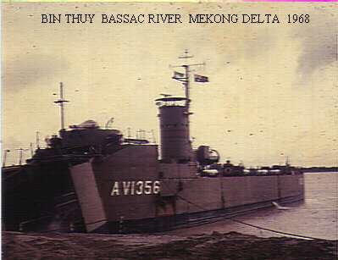At this time the crew were taking R & C leave, usually in Vung Tau or Saigon. I took my R & C at Can Tho and spent 7 days staying with the Australian Training Team personnel who operated out of Can Tho. The leave was organised through Maj. "Curly" Sullivan who was one of my Directing Staff at Canungra the year before. There were only Four Australians in IV Corps and they had a little house in Can Tho. The house was Two story with the entertainment area downstairs and
bedrooms upstairs. Above the stairway was a cargo net full of barbed wire and pieces of bent angle iron. If the place was attacked one retreated to the top floor and pulled the release rope and the stairway became blocked. As an extra precaution there were two "Claymore" mines mounted near the ceiling at the head of the stairs and aimed down the stairs. These could be command fired and anything on the stairway became "Swiss Cheese".

I had a good look around Can Tho and the hinterland. The entire town had the smell of Death, misery and despair. There were many examples of "To save the village we had to destroy it".

Two of the advisers were training VC defectors (Chieu Hoi's), who had come in out of the cold under the "Open Arms" program, and on a couple of occasions I went with them on a training/regular patrol dressed as they were in black. On one of these patrols we stumbled into the rear of a South Vietnamese Marine Company set Ambush and we were told very politely and firmly to "go find another piece of real estate". The SVN Marines were one of the few professional units in the SVN Forces and we moved very quickly out of their area.

The principal agency in Can Tho was CORDS (Civil Operations and Revolutionary Development Support). The more I was told about the structure of this agency the more I became confused. It was a civilian operation aimed at "pacifying" the rural areas of Vietnam yet came under Command of the Commander USMACV, General Westmoreland), the idea was to pacify the areas so as to deny the VC a power base amongst the Delta peasantry, while at the same time USMACV was waging a war of "attrition" against the VC. The only thing that was wrong with that set-up was that while CORDS was "pacifying", the Military, principally the ARVN, was killing, indiscriminately, by way of misplaced bombs, Rockets, Napalm and bullets the very peasantry that CORDS were "pacifying". As a result more and more peasantry were aiding and abetting the VC. The CIA were also involved in CORDS and many of the CORDS staff were ex-US military. CORDS people I spoke to were adamant that the policies in place would pay good dividends. The US Army people I spoke to said that "the competence of CORDS was inversely proportionate to the size of the organisation - and CORDS was becoming very big".

I went out to a few hamlets with some of the CORDS advisors in an "International Scout" vehicle and although we sat on the ground and shared a cool drink (local) with the villagers there was always a look of contempt and/or antipathy on their faces. The question of the mid
60's in Vietnam was always present - were they VC or not ? I certainly did not know and neither did the Advisors.

The only real R & C I had was on the Friday afternoon when we went by Chopper to Long Xyuen to stay with a group of Australian Medical staff. The group would spend three to six months at the Hospital in Long Xyuen and were volunteers from various hospitals in Australia. They were accommodated in an ex- French Chateau set in most delightful surroundings. When we were met we were asked to hide our weapons as weapons were not needed in this town. It appeared that Long Xyuen was in a province that was more or less controlled by a religious Sect that did not like the South Vietnamese Government or the VC or North Vietnamese and both sides would be tolerated, so long as there was no trouble.

The Australians were looking after the Children's' Ward at the Hospital and were quite aware that they would probably be caring for the children of VC but it did not bother them. Their mission here was one of medical aid to the patients whoever they maybe.

I visited the Children's Ward of the hospital where the volunteers were working and each bed was occupied by two children head to toe and a member of the family was sitting on a stool next to each child. If one of the family was missing for some reason and the child went into a convulsion and died then the family member of the other child simply sat there and showed no emotion at all, as they only had interest in their child. One of the kids I photographed was from a peasant family (whether it came from a VC family was not known as questions were never asked of the family political ties by the Australian volunteers) who had been bought in with a timber sliver in his stomach and had gone septic to the point where they did not think they could save him. Medical supplies were always difficult to obtain. Supplies from Australia went "missing" every now and then. (Note the ration can being used as a drain pan in the photo above.)

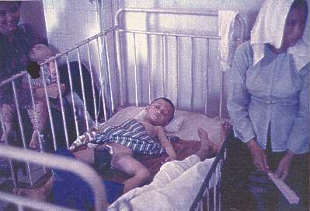

Whether the wound was caused by military action was not known but apparently the first thing a parent would do is to take the child to the village "Witch Doctor" who would apply mud to the wound. As the condition got worse the next step would be a visiting "Herbalist" who would give the child herbal treatment and the final step was the Govt. hospital at Long Xyuen. Had the child been bought in at the first instance recovery would have been completed very quickly, but as it was explained to me "We always get them as a last resort!".

We had a party that night at the US Aid unit and one of the American civil staff gave me an insight into US Aid to the peasants in the Mekong Delta: This fellow was a "hands on" type who had little faith the US Government approach of using Technology and Money to "fix" the lot of a peasant community in a war torn and undeveloped country. He was ex US Army and had completed a tour in Vietnam in 1964 as an Advisor and had since retired and came back "in country" as an advisor with the USAID program.

I cannot remember the full context of the conversation but the following should suffice . "We don't know how long the peasant has been living like this, possibly since time began, but certainly since the 30's. They have been fully exploited by the French, subjugated and massacred by the Japanese and then exploited again by the French, Vietnamese Government, Viet Minh and Viet Cong, none of whom saw anything wrong in shooting them for the slightest transgression. The French have gone and the Viet Minh have been replaced by the Viet Cong. In 1945 Ho Chi Minh wanted US support and would welcome 1,000,000 US Troops but not the French as the occupying Force.

At this time the Vietnamese were very Nationalist with a great desire for independence, and in his declaration of Independence speech in September 1945 Ho Chi Minh even quoted the American Declaration of independence, but the Allies promptly proceeded to restore French rule and it became a policy of disaster. The Viet Minh then began hit and run operations against the French and the Vietnamese peasants became pawns in a game of death and destruction by both sides.

The Peasant invariably had only a small plot of ground and his yield of food was only enough for subsistence. Because of the high death rate of children and his desire to have sons to work the plot it almost became a fact that as soon as he looked at his wife she became pregnant. A curfew was instituted in the early 30's between 6PM and 6AM which also helped the birth rate. If they ventured outside their homes during curfew they were shot on sight which seems no different to the 1960's.

With the departure of the French in 1954 a Geneva agreement partitioned Vietnam with the Viet Minh in the North and the Bao Dai regime in the South and the partition became another blueprint for disaster. The Vietnamese Communists in the North began executing thousands of Landlords in a land reform program and in the South the Viet Cong (ex-Viet Minh) began assassinating Govt. officials and their families and peasants who incurred their wrath for whatever reason. Between 1954 and 1962 the peasant of the Mekong Delta lived a more miserable life than he had previously in that the Govt. would simply take a portion of his Rice and shoot or imprison him and the VC also got into the act by not only taking the Rice but in some cases wanting a Son or two. If the peasant refused to give up his son either the peasant was shot or his son or both. The only difference between Govt. and the VC was that the VC always gave a receipt for Rice taken. If another VC cadre came around he only had to produce the receipt and he did not have to supply rice but if Govt. troops came around and he either produced the VC receipt or they found it then he was summarily executed - the obvious thing to do was destroy the receipt but this only became another problem.

The US became involved in the mid 50's by way of civil aid and this was another disaster. Washington sent out a group of desk bound academics to find solutions to "democracy" in South Vietnam. These academics could only think in terms of two solutions - Technology and Money.

Millions of dollars’ worth of "Briggs & Stratton" petrol engines were sent for irrigation purposes, but the peasants had been using their own form of irrigation for centuries and they found that by mounting them on their canoes & boats and fitting a home-made propeller they could eliminate the drudgery of rowing. We sent out tractors and other mechanised equipment that they did not know how to use when hand implements would have been appreciated and in any case they usually ended up on the foreign owned properties. We even sent out millions of leaflets written in Vietnamese containing instructions on how the equipment was to be used but the peasant could not read.

By far the biggest problem associated with US Aid to the Mekong Delta peasant was medicine. We gave it in good faith and teams to administer it, but we never realised the impact that it would have on the peasant. The death rate of the peasant children dropped dramatically but we forgot to tell Mum and Dad not to look at each other every night and their number of Children began to increase. But he still had the same plot of ground and he still had to supply the "vultures" with their needs and as a consequence he became a fence sitter. He did not give a damn for either the VC or the South Vietnamese Government and the only thing that mattered was the survival of him and his family. He cared for no one else."

We had a swim the following day at the CIA's Communication centre. After a very relaxing weekend we left again on the Sunday afternoon to return to Bin Thuy thinking why couldn't the rest of Vietnam be like Long Xyuen. The last day of my R & C came up and I flew back to Saigon by "AIR AMERICA" Pilatus Porter. AIR AMERICA, although fully owned by the CIA is also a full member of the IATA and issues tickets to its passengers. My flight bag was booked in and there was a waiting room (with the inevitable Coke machine) in which I sat with two Special Forces men. As we went to board the Aircraft the only words spoken were by the attendant at the cabin door asking us to "please remove magazines and loaded rounds from your weapons before boarding the Aircraft".

Saigon was about 90 minutes by the Porter type aircraft which are not renowned for their speed but are for their very short Takeoff and landing, it took all day to get to Saigon as this aircraft dropped into the most unlikely airstrips to take on and let people off, all of whom were

heavily armed. Landing at Saigon I was advised the "STEELE" had sailed for Vung Tau so it was only a matter of hopping onto a RAAF Caribou to catch up with the "STEELE".

DONG TAM

We carried out quite a few tasks to Dong Tam on the Mekong River. It was much closer to Vung Tau than Bin Thuy. Dong Tam was the HQ of the Mobile Riverine Force (MRF117) and two Brigades of the US 9th Infantry Division. During 1966 MACV had decided that US Ground Forces should be committed to the Mekong Delta as, although the South Vietnamese forces were holding their own, they were not wresting any control of the local population.

Approximately 40% of the delta population was under VC control.. The IV Corps Delta was the Rice basket of Vietnam but, because of VC actions, the US began importing rice into Vietnam in 1966. Since the US Navy was already committed to Interdiction operations in the Delta it was only natural that they combine with the US Army and become a Riverine Force. The French had used River Assault Groups with much success during their war in the 50's. The question at first was not if the force was to be raised but where to put it.

It was finally decided that as no land was available then the force would be afloat all the time. There were some problems with this due to rotation of personnel and troops being cooped up aboard ship for long periods so the next progression was to "dig a bloody big hole, fill it with water and make a Port" which is exactly what they did do. (See the MRF section)

A very little Dredge was used at first to create an environment in which it could operate and once this was achieved two very large Dredges were towed from the States and proceeded to "dig and fill a bloody big hole". The hole was rectangular and each side was approx. 700 yards. When this was completed a harbour was created which could not only take three heavily laden LST's but also Coastal Tankers drawing about 10 feet, Then they put some wharves around the perimeter of the harbour, two relatively large beaching ramps, built an airfield that could take a C-130 and then began to move Troops in. The main vessels of the MRF always anchored out in the main river and at night were totally blacked out.

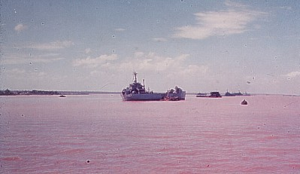
USS "WESTCHESTER COUNTY" was mined in Oct 68 with 26 killed.

The inner harbour would hold LST's on Logistical re supply, Hovercraft, Swamp Buggies and the Gun Barges which carried the 105mm guns which accompanied the main force when it moved on the waterways. The building of the base attracted the attention of the VC and the base was regularly Mortared and/or hit with Rockets. Consequently the finished base was dug

in and everything was covered with sandbags. The Airfield was adjacent to and virtually on top of the Beaching Ramp and was always a good target.

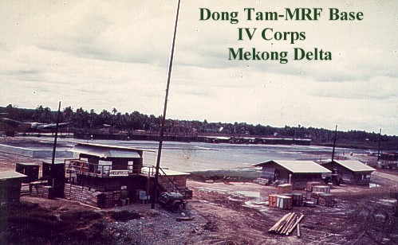

Cargo carried by "CLIVE STEELE" varied from General Cargo to the singular cargoes of Beer and Ammunition. Unloading of any cargo was done by a Shore Party from the 9th Division and was routine in all cases except that pertaining to Beer. On every occasion that we had a cargo of beer the same procedure took place - The Pallets of beer were removed from the LSM by Rough Terrain Forklift and the cartons were held in place on the Pallet by wire straps. After leaving the Ramp there was a medium rough rise to the holding area and at some time during the unloading a pallet of beer would "slip" off the forks and roll to one side.

The Forklift driver would then "attempt" to pick it up again and in doing so would break the restraining straps and the load would fall again leaving one ton of beer laying on the ground. The "spilt" load was then left for someone else to pick up. At that moment heads would appear from holes in the ground, from boats and men would come across from the airfield and in a very short time there were no loose cartons of beer laying on the ground. It happened every time and much of this warm beer was consumed immediately .

We were also sprayed again while en-route from Saigon to Vung Tau and the procedure was the same as when we were sprayed in 1966. The defoliation of the riverbank was now beginning to take effect in that during 1966 the defoliation removed the leaves and then the leaves returned and the bank was sprayed again. Now, in 1968, same of the larger trees were dying but nature was trying to defy all efforts to make the banks a wasteland as small shrubs were still trying to reach maturity.

As in 1966 we were never warned of the spraying and since we were never warned we had no fear of the spraying. It is interesting to note however, that during 1966 and 1968-69-70 I never saw any crew members of civil ships move around their ships while transiting the Saigon River and we put this down to either company rules ie. insurance or a natural desire not to be hit. Our own Standing Orders aboard the "CLIVE STEELE" required visible movement of the crew to be at a minimum but we had three gun crews in exposed positions as well as the bridge and there was always movement on the exposed decks by engineers and deck crew in the normal performance of their duties. US Army vessels also were sprayed as well as US Navy patrol craft but US Military Sea Transportation Service (MSTS) vessels which were civil crewed were also devoid of personnel moving around in exposed positions.

My own theory on the lack of movement on civil shipping, including MSTS ships was that all civil shipping was under operational control of the MSTS which had a signal station at Cap St. Jacques and a pilot was put aboard these ships and that the instruction for no movement by the crew was given by the pilot. Whether such instructions included "beware of defoliant spraying" as well as "beware of hostile fire from the riverbank" is conjecture on my part. My copies of "Saigon Port Instructions" include no reference to defoliant spraying and my copy of the MSTS Manual of South Vietnamese Ports does not include any reference but they do contain such information as to the location of the USO, beware of the fresh water and where film can be developed.

We also carried more drums of defoliant to Vung Tau from Saigon and these were similar to the load we carried in 1966 - some loose and leaking as well as complete pallet loads. As was usual some of the drums were leaking but not as a result of corrosion but because of damage by forklifts. They also made a mess of the deck. We also carried, possibly the same drums, from Vung Tau to Dong Tam to the 9th Infantry Division and here we could see the result-of massive tree and vegetation defoliation. The unloading of the drums was carried out by Rough Terrain Forklifts and as was usual a lot of the mixture was all over deck and our deck crew had a great mess to clean up. The Southern bank of the Mekong River opposite Dong Tam had been defoliated to a depth of about one mile and it resembled a moonscape - no vegetation at all except the occasional tree stump. Since the area defoliated was rectangular it was obvious that the spraying had been carried out by Helicopter but it was also obvious that it had been sprayed every other day or the "cocktail" mix was extremely potent.

One night we anchored in the river behind the MRF LST's and I had the 8-12 watch. About
2330 a Rocket barrage begun from the bank opposite the base. Notifying the Skipper and sounding Battle Stations I then awaited instructions from the Harbourmaster at Dong Tam and in the meantime we all watched an amazing sight. The rockets were being from about a mile back and were on a low trajectory. They were not interested in us or the MRF LST's - just the base. The rockets were passing over us and exploding in the base perimeter. The MRF LST's then opened up with their main armament which was four 2 x 40mm Bofors and then the PBR's which were on Mine patrol opened up with .50 Cal MG.

Gunships then appeared overhead and night became day as they sought to pinpoint the VC but it was the same as in every attack. The Rockets were put in place and then command fired from a position far from the Rocket sites. The VC had gone long before the last set had taken off towards the base.

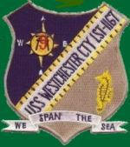On yet another occasion one of the MRF Support LST's, USS "WESTCHESTER COUNTY" was taking on potable water at My Tho. The water was bought out by a Lighter of the Vietnamese Navy. Either coming out as a crew member, swimming out or towed out by the Lighter was never established but the VC put a large mine on the Hull of the LST about 20 feet forward of the Bridge. When it exploded it killed 21 including nearly all the LST's complement of Petty Officers.

My Tho was a "secure" city with security guaranteed by the Vietnamese Army. At Dong Tam the MRF ships had a "Mine Patrol" which simply circuited the line of ships all night dropping percussion grenades at random to deter VC swimmers.

On a run down the coast from Vung Tau to Bin Thuy one night about 2300 I was on watch and we were about five miles off the coast when I noticed, off the Stb. Bow, a pinprick of bright light. The light was moving up the coast and appeared every three seconds. As we watched, the flash was on our beam, and then continued northward until it disappeared. I was not to find out what that light was until the following year when serving with the US Army.

We had thought that the "STEELE" would return to Australia but this was changed and the crew would be relieved by air. Every US Navy LST that we came across had a ships Plaque or Mug or "T" shirt of which most of us obtained and one in particular was LST 525 "CADDO PARISH" and the motto for this LST was "NO BEACH T00 HARD TO REACH" which, of course, was on the Plaque, Mug and "T" shirt. I had been thinking for some time to have a Plaque of our own which would be better and an ink drawing, I think it was drawn by Jack Peel on the "STEELE" in 1966, which more or less gave me an idea.

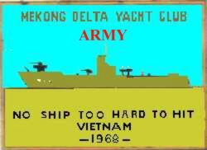During our running up , down and around the coast and waterways of South Vietnam we had came in "contact" with a few ships, wharves and beaches. This is not being derogatory to the Skipper, Wally Blumenfeldt, who was both a
gentleman and probably the best LSM "ship handler" we ever had but we did have these 'contacts' mainly due to high rate of current, wind and difficult berthing instructions. In 1966 a drawing was produced, I think by Jack Peel of the "hits and near misses" that we had. The drawing showed the "CLIVE STEELE" going up the river at Saigon leaving a trail of damaged and sinking ships in our wake. On the shore was a very large American gun aimed at us and the gunner was just about to fire when the OIC came up yelling "For
Christ sake! - don't fire - they are our Allies". As a result of that drawing we had two plaques made. One was the normal type of plaque with the ship imposed on an Anchor background and the other was a square plaque.

The new crew arrived and my relief was Doug Iffla whom I had served with the year before on the "BRUDENELL WHITE". After a brief handover it was out to Tan son Nhut and aboard the 707 to come back to the "world".

POSTSCRIPT

When 32 Small Ship Squadron was disbanded the "CLIVE STEELE" was sold to Pacific Logistics. She was outfitted and used to carry cargo from Singapore to Phnom Penh in Cambodia. She was subsequently hit by rocket fire on the Mekong River - beached and abandoned. Her subsequent fate is unknown.

AV1354 "BRUDENELL WHITE"

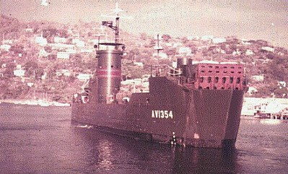

PORT MORESBY - NEW GUINEA OCT 64

RECORD SEPIK VOYAGE BY ARMY LANDING SHIP

LIFE AFTER 32 SQN.

This account is from official sources and describes a most unique voyage by an Army landing craft, AV1354 "BRUDENELL WHITE", commanded by Captain Blumenfeld with Captain E.A. Shaw, First Mate, and Lieut FW. Thorn, Chief Engineer.

In October 1964 the Army Landing Ship, BRUDENELL WHITE, on assignment to supply Army surveyors operating in the Northern Highlands of New Guinea, became the first vessel of her size to travel 350 miles up the Sepik River. This performance surpassed, by 130 miles, the previous record which was set by two Australian ships, HMAS WARREGO and PARRAMATTA both 200 feet long and of 500 tons during World War I, whilst the BRUDENELL WHITE measures 203 feet and displaces 1000 tons.

Early History of Sepik Voyages

Sepik River history records also that, in 1909, the German ship CORMORAN, with a displacement of 1 640 tons, travelled about half the distance of the new record. Since 1880, about ten ships have navigated the Sepik River for any appreciable distance. Only motor launches have gone as far as the May River junction where BRUDENELL WHITE ended her outward trip. The BRUDENELL WHITE's voyage set a record likely to stand for many years, and disproved theories long held about the feasibility of navigation of one of the longest water ways in Papua and New Guinea.

Objects of Voyage

The main purpose of the journey was to take supplies and equipment to the Survey parties working inland from the May River and the Sepik . The most essential items were drums of aviation spirit required by the survey helicopters, and the plan was to set up fuel dumps as the

BRUDENELL WHITE progressed. Fuel not used was to be collected on the return voyage for return to the storage depot. The ship also carried tools, markers, beacons and instruments, needed by the surveyors to carry out their work in the Northern Highlands. Normally, these materials would have been air-freighted to the nearest landing strip and then moved by helicopter to a dropping zone near where the party was operating, but it was then decided that the quantity of supplies and equipment to be transported warranted the use of a landing ship and that, as the same time, the voyage could take the form of a technical reconnaissance expedition. The aim was to travel as close as humanly possible to the seat of the survey operation, which extended from Green River down to Telefomin.

Preparations

About a week before the voyage began, Capt. Blumenfeld and Capt. Shaw were taken on a familiarisation flight by light aircraft along the entire course of the river. This aerial familiarisation provided them with a great deal of valuable information, which they were able to use to advantage on the actual trip. They were able to note the banks, conspicuous landmarks such as villages, current flow and passages that would have to be taken. Other features -Tributaries and Mooring points were also memorised or marked on a map. The passage marked from the air later proved remarkably accurate and, in one case, at Tauri where there is an island with a false lee, knowledge was gained without which the BRUDENELL WHITE may have gone aground.

After last minute briefing by Army Survey officers at the Wewak camp, the LSM (Landing Ship Medium) was prepared for the voyage, which lasted about a fortnight and covered a distance on water of more than 700 miles.

The previous month had seen a building up of rations, stores and the survey supplies. Water was to be a major problem so the ship's ballast tanks were flushed and filled with 30,000 gallons of drinking water. In addition, two iron tanks, with a total capacity of about 3,000 gallons, were made and placed on deck. Water was taken at Kairuru Island, a Mission Station which affords the only large watering place close to Wewak. While the tanks were filled from a mountain spring, the crew spent the night on the island and entertained mission staff and children with films on the deck of the ship. To supplement the reserves of water, awnings were erected around the superstructure with gutters to catch run-off from the rain.

In an effort to make the voyage bearable for the crew, all ventilation inlets were blanked off to exclude mosquitoes and insect repellent was liberally applied. The ship is air-conditioned, and the crew have long since adjusted themselves to working and living in the cramped conditions. The landing ship left for the mouth of the Sepik from Wewak, about 60 miles and six hours away.

Under Way

Where the Sepik joins the sea, the entrance was found to be about a mile wide and extremely deep. The time was 10 am and there were 70 miles to be covered to the first Government post at Angoram.

The BRUDENELL WHITE, a former United States Naval vessel, carries a crew of 41 and, for administration purposes, the ship is organised as an Army platoon. She is operated in the same way as a merchant vessel - with a master, three mates, four engineers, a bosun, quartermaster sergeant, and a number of sapper seamen, craft engineers, fitters and two signallers to operate radios.

Mr Bill Tebb, a well-known identity of Papua New Guinea who is master of a Government trawler, provided valuable services as pilot-adviser. Mr Tebb, who has been in New Guinea for almost 15 years, knows the Sepik well.

The most important special equipment aboard the ship for the voyage was an echo sounder, an integral part of navigation aids on all Army Landing ships.

Heads Human and Prawn

By later afternoon on the first day, the ship reached Angoram and tied up for the night. The next morning the voyage was resumed and, after a couple of hours sailing, BRUDENELL WHITE was passing a spot named Japanaut. This stretch of river has the reputation of being dangerous for navigation because of concealed rocks and other hazards, but it was negotiated without incident. From then on, numerous small villages were sighted and wide-eyed inhabitants were a regular sight. The crew were offered shrunken heads at one village. For those interested in such curios, the price was not low; from $40 to $100 per head. Capt. Blumenfeld noted that the inflated prices for these articles were largely due to the influence of American anthropologists eager to obtain them for research purposes.

At Mindimbit, large supplies of prawns were purchased. These Sepik River prawns are even bigger than the Australian deep sea prawn and just as tasty. Quantities of these could be carried to supplement normal rations without fear of them deteriorating. The BRUDENELL WHITE has a permanent deep freezer installed below, and has a special refrigerator on deck.

Unusual Cargo

About 200 miles upstream at Pagwi, a landing place for the Administration Station at Maprik and 34 miles inland from the Sepik, the ship landed a tractor for the Administration. This operation had its humorous as well as its apprehensive moments. To off-load the vehicle, the Landing Ship had to sail directly onto the beach, where local inhabitants set about building a ramp of earth, reinforced with logs. All watched anxiously as the tractor, valued at approximately $3,000, was readied for the drive ashore by a New Guinea driver perched about 10ft above deep water. It moved off slowly, then began to rock as it plodded down the earth ramp. It teetered and yawed many times, apparently about to pitch into the river, before it finally reached solid ground and was moved to a safer spot.

The small population of Maprik, headed by the Assistant District Officer, had come down to meet the ship, and an invitation was immediately extended for a barbecue at Maprik. It was gratefully accepted, and as many of the crew as could be spared set off later for the village. The barbecue proved a huge success.

Previous Record Limited Reached

About 20 miles further upstream is Japandai, the point to which HMAS WARREGO and PARRAMATTA penetrated when looking for a reported enemy raider during World War I and from where they returned to the sea without sighting their quarry.

After Japandai, the ship sailed on to Ambunti, the last Administration Station on the way up- river. Again the crew were generously entertained by the local inhabitants, including the District Medical Assistant, Mr Frank Neville, and his wife. The Assistant District Officer, Brian McCabe, gave valuable help to the party.

From this point on, expert navigation assumed even greater importance. The greatest depth had been 25 fathoms (about 150ft) but the river was to prove much deeper.

Legendary Whirlpools

About this point, the ship began to meet debris such as logs which, although not able to damage the steel hull, could have fouled the propeller. But fortunately nothing of this nature occurred.

So far the voyage, although not uneventful, had been reasonably straightforward. However, by the time the BRUDENELL WHlTE reached Ambunti, 235 miles up the Sepik, extensive whirlpools and rock hazards were encountered. The whirlpools, from 30 to 40 feet deep, varied from between 10 and 1 5 feet across; big enough to engulf a native canoe. Local people attribute the whirlpools to the influence of submerged rocks which, with river currents, create turbulence. However, it was discovered that the true reason is exactly the reverse. The BRUDENELL WHITE's navigators noted that when the whirlpools began to appear in any great numbers, there was a corresponding sudden increase in the depth of the river at that point.

Mystery of the Whirlpools Solved

Throughout the journey, the echo sounder had been of great assistance in helping select most favourable channels through which the ship could pass and, on the final stages, was to be invaluable in taking depth readings and chart references. It helped prove conclusively that, in the Sepik, whirlpools are not due to the turbulence caused rock shelves and bars, but to currents in the deeper water.

The Sepik was still quite wide in this region, but in some stretches became very shallow making the echo sounder of little use. Captain Blumenfeld adopted a technique of referring to vegetation along the banks for an indication of the deep channels. He found that where the river narrowed at the bends, he could guide the BRUDENELL WHITE through by keeping close to the edge on which grew the tallest trees. The swampy patches with low shrubs indicated little depth at that spot.

Altitude 168 Feet

It was observed that, by this time, the LSM had climbed 168 feet from sea level which accounted for the strong (5-6 knot) current. The next calling point of any size was Yamban where the greatest depth of 186 feet was recorded. As the ship has a six foot draft, there were
30 fathoms beneath the keel. After a brief stay at Yamban, the Landing Ship proceeded to
Oumi Village.

There are two villages of the same name, the major settlement being some miles inland on a lagoon. Missionaries there warned of dangers likely to be encountered further on, so an outboard craft was sent ahead to take soundings with lead and line. The boat returned with a favourable report and it was considered safe for the journey to continue. By this time, the drums of the helicopter fuel, known as Avgas, were being unloaded in batches at a number of appointed zones, and the ship headed off again with her final destination, the May River Junction, now only about 70 miles away. This stage took another day and, by the time BRUDENELL WHITE arrived at the May River Junction, she had covered 469 miles in just short of a week.

Recent Cannibalism

The village at May River is Yuambi and the company of the landing ship was told they were survivors of a tribe which, some years ago, murdered a rival group and promptly devoured them. Although the group has since been brought under the law, those remaining at Yuambi were still considered primitive and uncivilised. Nevertheless, once they had overcome their awe at the biggest ship they had ever seen, they were eager to assist with such tasks as mooring the ship and bringing supplies ashore. While these jobs were going on, one of the outboard boats, a fibreglass craft of about 1 5 feet in length, was sent with a load of aviation spirit to the Administration Post about 20 miles up the May River.

When the boat arrived at the Government Post, it was met by the local Patrol Officer, Tony Pitts, who requested that permission be obtained to carry out a sick missionary by Army helicopter. It was proved and the patient was flown to Green River where a light aircraft waited to carry him to Lae for medical attention. Meanwhile, Captain Blumenfeld had been observing the river level closely. It was to drop 7 feet during the five days that BRUDENELL WHITE remained at the May River Junction.

LIFE AFTER 32 SMALL SHIP SQUADRON

This photograph was taken at Singapore in 1975. The "Brudenell White" had been sold to Pacific Logistics of Panama and is shown here at Singapore after being modified to the owners requirements. It has been reported that she was sunk on her maiden voyage to Phnom Penh Cambodia by rocket fire on the Mekong River.

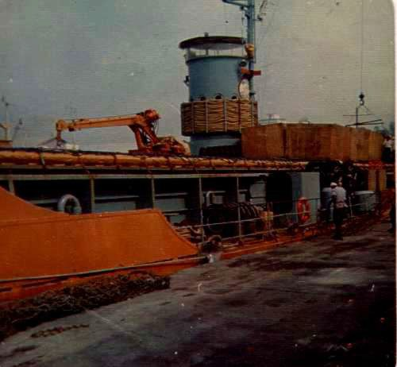

The Forgotten Fleet 32 Small Ship Squadron

AV1353 "HARRY CHAUVEL"

There is only photography at this time. Photos of AV1353 have been supplied by "Dazz" Graney- ex AV1353, 32 Small Ship Squadron

"HARRY CH<\UVEL"
VIETNAM ..,

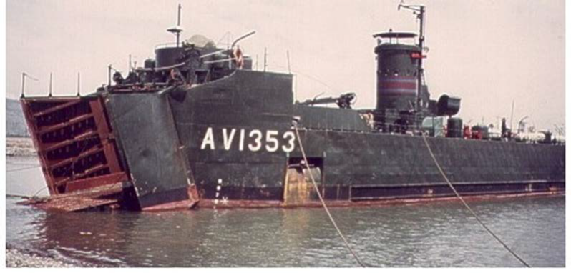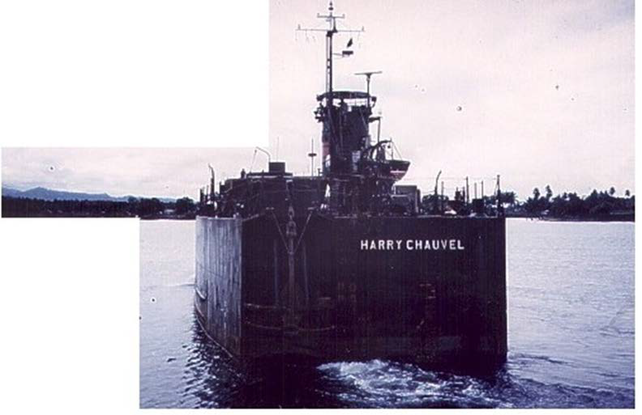AV1353
MADANG
NEW GUINEA 1965

-·

32 Small Ship Squadron The Forgotten Fleet

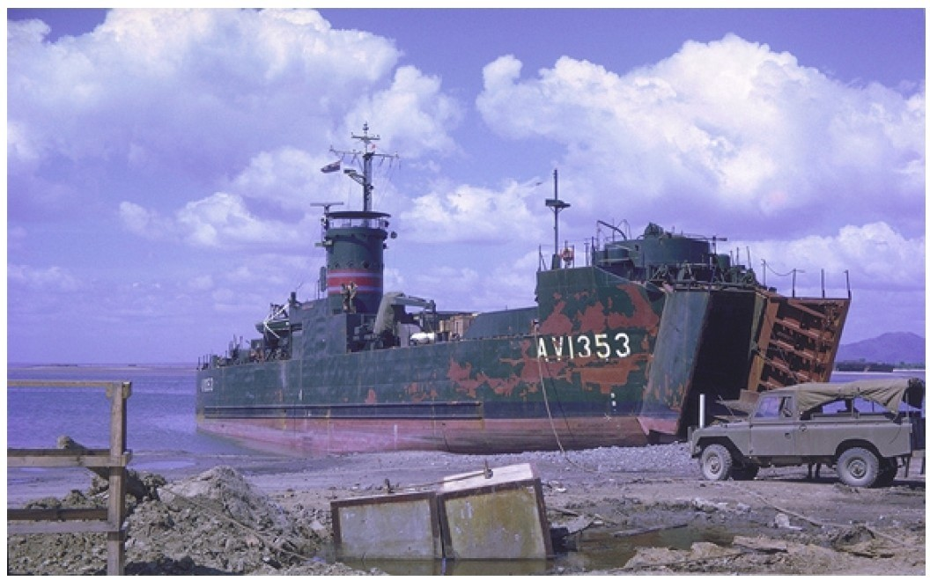

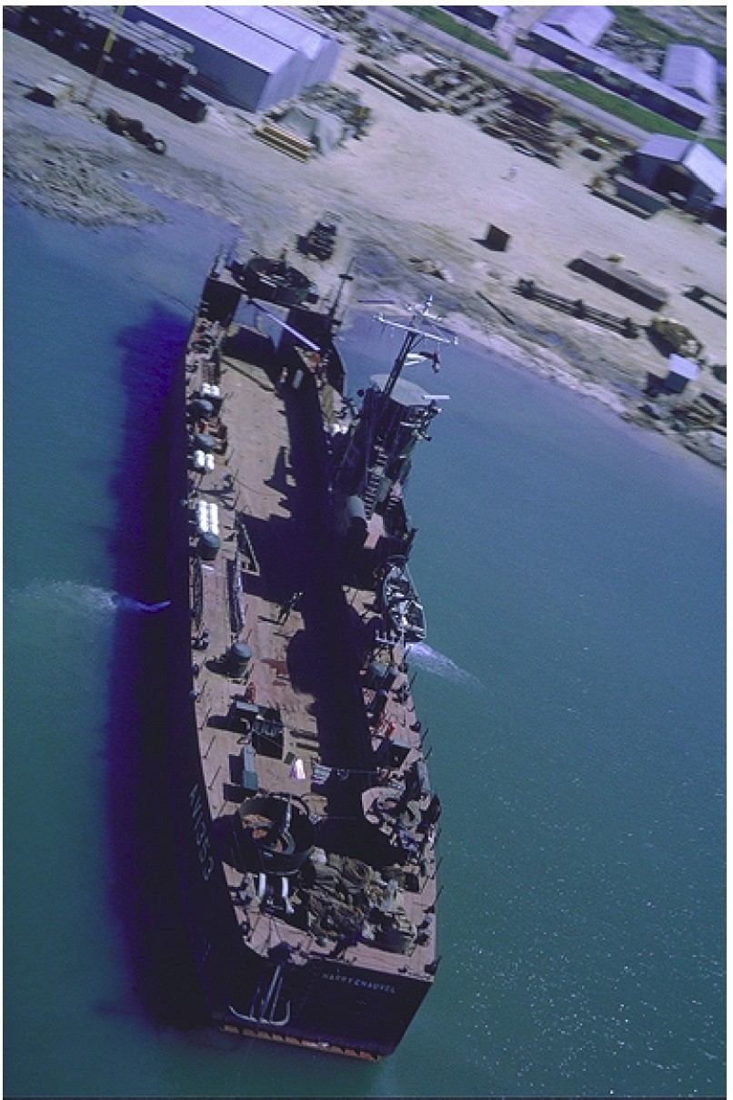

The Forgotten Fleet 32 Small Ship Squadron

AV1355 "VERNON STURDEE"

There is only photography at this time. Photos courtesy "Dazz" Graney - ex av1353 32 Small
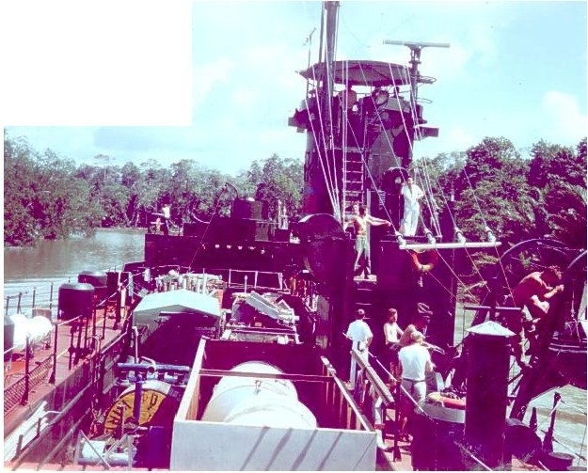Ship Squadron and Phil Cannane

AV1355 "VERNON STURDEE'' OIL RIG TO KARUMBA GULF OF CARPENTARIA
1963

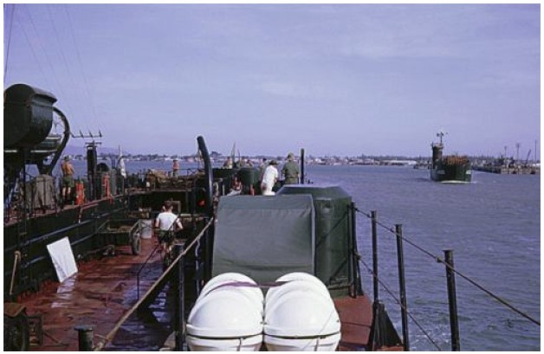

AS3051 "JOHN MONASH"

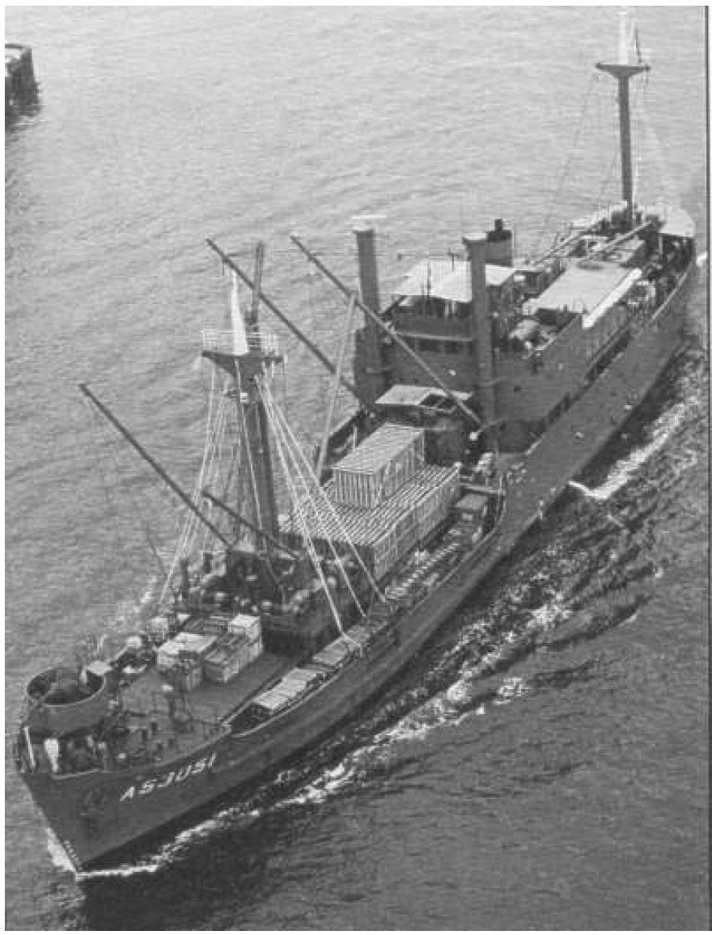

World War 2 History

THE UBIQUITOUS LSM

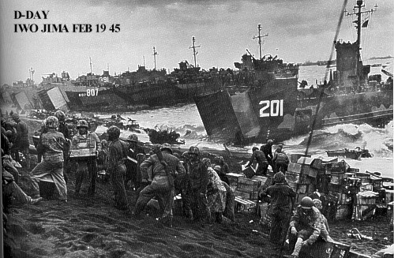

After the British failure in conducting an Amphibious assault at Gallipoli in 1915 there was no serious consideration regards large-scale amphibious operations by any nation except Japan. In 1939 a study was made within the British Admiralty on "requirements for landing troops on hostile beaches in Europe. The conclusions were "Raids might be undertaken from submarines in a matter of weeks, a raid by a Brigade could not be staged under six months because of a lack of landing craft and two years would be required to prepare for a Brigade Assault with the aim of occupying territory"

The United States believed that any future European war would be a modern version of WW1 and prepared accordingly. In regards to a Pacific war the US believed that it would only require the Pacific fleet to advance across the Pacific and land small numbers of US Marines on the islands after the island bases were reduced to a shambles by the heavy naval gunfire and by bombing by U.S. aircraft. The U.S. Marines trained for the possibility of these events unfolding. At the time of Pearl Harbour the USN did not have a single oceangoing ship that could beach and discharge troops and equipment ie. tanks etc.

In 1940 the British, now that the threat of Invasion by the Germans had lessened greatly, began to look at mounting a cross channel invasion and began a study. The results of that study ended in a team going to the United States asking for the building of two types of landing ships they had a design for, under Lend Lease. These ships to be built were Landing Ship Tank (LST),328' and Landing Craft Tank(LCT) 128'. They wanted 200 of each. The United States rejected that assistance as they already were heavily committed to Lend Lease and the British team returned home to report he failure to acquire assistance. A few weeks later Pearl Harbour was attacked and the ball game changed dramatically. The decision was reversed and the British requirements would not only be met but there would also be a construction program for similar numbers and types built for the U.S. forces.

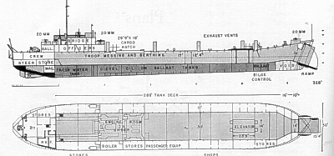

It is not known how many LST's were transferred, under Lend Lease, but some 1000 were built, mainly for the USN. With a design speed of 11 knots they were not capable of operating as an integral part of an Assault Force, but were used as such in the Pacific during WW2, particularly with MacArthur’s 7th Fleet Amphibious Force. They were also utilised as Hospital ships, Troop carriers, Repair ships etc. In the USN they became known as Large Slow Targets, as their max. speed was only 8/9 knots.

The British built some 20 LST's. These ships differed from the US built ships in that they were 20' greater in length but more importantly were steam driven with a speed of 13 knots.

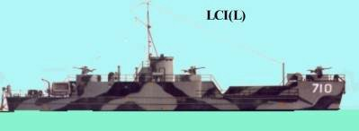

Another Landing craft that was important to the LSM history was the LCI(L) -"L" being Large. This vessel had a speed of 14 knots and a length of 159'. It was designed to carry assault troops. In addition to the crew of 25, the LCI(L) could carry 180 troops and land them directly onto a beach using two ramps, lowered on each side of the bow. The original British design had no sleeping accommodation for the troops as the LCI were to be used only in short range operations ie. crossing the English channel and never far from a shore base. the British design considered that benches were appropriate for the troops. All American built LCI's installed for both crew and assault troops. They were considered as not suitable for operations exceeding 100 miles. In the Southwest Pacific, necessity required continuous use in waters very long distances from shore/repair bases. some 800 of these craft were built. In late 1943 a decision was made that a vessel of comparable speed to an LCI(L) be designed and built that could accompany LCI's to an assault beach and carry tanks. Thus the Landing Ship, Medium was conceived, designed and in 1944 they were being built all over the United States.

LANDING SHIP MEDIUM (LSM)

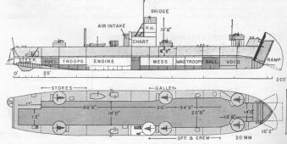

LSM PHOTO ALBUM

The following is an extract from the book "MacArthur's Amphibious Navy" written by Vice
Admiral Daniel Barbey who was commander U.S. 7th Fleet Amphibious Force

"The U.S. Army built, many years before, the imposing Fort Drum with 18-foot-thick concrete walls,14-inch guns, and many interconnecting underground passages. U.S. warships had knocked out the big turret guns, but the Japanese garrison with smaller guns, plenty of ammunition, and adequate food and water were in a good position to withstand a long siege. Plane bombardment and naval gun fire could keep the defenders within the fort but couldn't pierce its interior. A landing force could get on top of the fort, somewhat like being on top of a turret, but at nightfall the garrison could emerge from some unexpected opening.

An extension of the idea used so successfully on Caballo was tried out. Under cover of planes and naval bombardment an LSM worked its way to one side of the fort and was held there by two landing craft. A specially constructed ramp was dropped from the superstructure of the LSM to the fort's top side. Men poured across it to stand guard at all the openings. Other men placed hose nozzles in ventilator openings and through them pumped
1,800 gallons of an explosive mixture of gasoline and diesel oil, with a time fuse. To keep the Japanese from emerging to see what was going on, planes kept buzzing the fort and destroyers made a lot of gunfire noise. When all was ready, and that was only a matter of minutes, the LSM with all its men and six accompanying landing craft withdrew to a safe distance. The time fuse was expected to function in about twenty minutes, and it did. But it was evidently a dud-the resulting explosion was but little more than a good-sized firecracker.

A conference was called aboard my flagship to determine what went wrong and what to do next. While we were assembling, perhaps an hour later, a terrific roar went up from El Fraile, followed by a fiery black cloud. It seemed as if the whole top of the fort must come off. Two days later a small party attempted to land, but it was still too hot for a reconnaissance. It was almost two weeks before the tunnels could be entered.

We learned later that the initial explosion had set off a fuse-like oil slick which, like a delayed timing device, had finally entered the fort's magazine with devastating results. Apparently the suffocating death of the defenders on Caballo arid El Fraile was too much for the Japanese garrison on Carabao, for they abandoned the island a few days later."

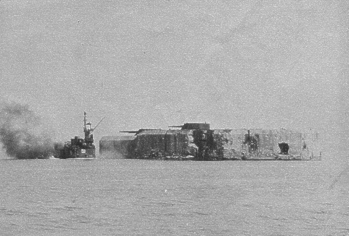

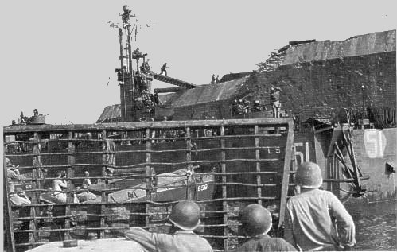
The assault

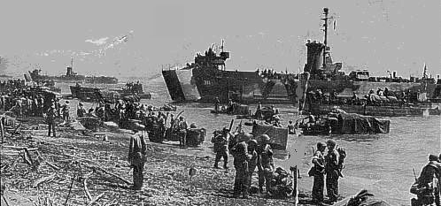
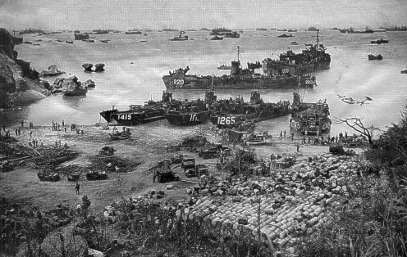This photograph is of a "backwater" assault in the Visayas, Southern Phillipines. All LSM's used in the Philipines were "loaned" to Gen. MacArthur by the Central Pacific Force. The last assaults by the 7th Amphibious Force during WW2 were the assaults on Tarakan and Balikpapan which were carried out by the Australian 7th and 9th Divisions.

One of the many logistic beaches used after the initial assault on Okinawa

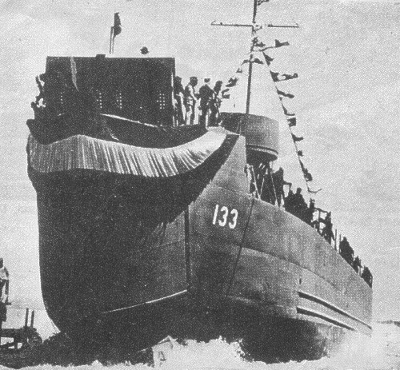
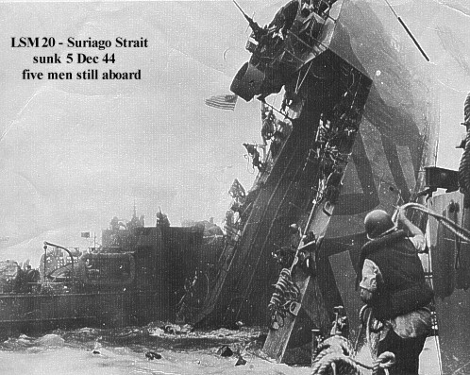Photograph of the launching of LSM 133. It was reported that this LSM took 11 days to build.

Photograph of the sinking of LSM20 by Kamikaze aircraft - Suriago Strait, Phillipines Dec 1944

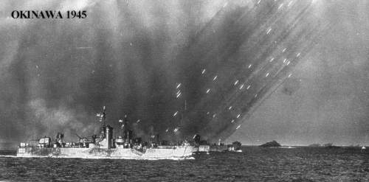
Photograph of the assault on OKINAWA showing a line of LSM(r)'s laying a barrage of 5" rockets on the beachhead and beyond

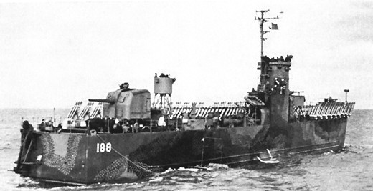
A photograph of a second generation LSM. These LSM's were completed as LSM's and then modified to take multiple racks of 5" rockets which covered the entire cargo deck. They were very effective in providing a creeping barrage for assaulting troops on a beachhead. Some 40 were converted.
All were fitted with a 5" gun aft.

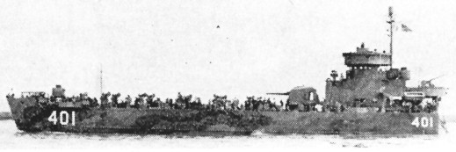
LSM(R) 401

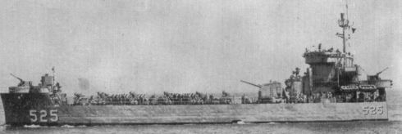

Photograph of a third generation LSM. This particular LSM(R) was converted while building with the bow doors being fully welded as a bow, bridge fitted aft and a 5" gun forward of the bridge. LSM(R) 525 "St. Francis River" served in Vietnam as did LSM(R) 409 and LSM(R) 536. Their dimensions were the same as for the LSM's. The armament was as follows:-
• 1 x 5" 38 cal dual purpose
• 4 x 40mm AA (Twin mounts)
• 8 x twin 5" rocket launchers
• (The launchers each fire 30 5" spin-stabilised rockets per minute
The crew complement was 7 officers and 130 enlisted men.

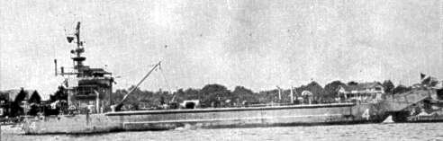

Photograph of an LSM converted to a Salvage ship after WW2. Many LSM's had a similar inglorious fate as rubbish barges, scows, dumb barges and one even had its place in history as the detonation ship at one of the Atom bomb tests in the Pacific.

LSM 45's Photo Journey
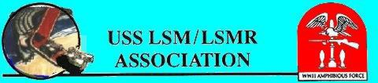

A Ghost ship from the past .. LSM 45: Built by Brown Shipyard, Commissioned 28 July 1944; Commanding Officer .. Lt.(j.g.) Bernard A. Rubin, USNR; No battle stars; Decommissioned 27 March 1947 Green Cove Springs, FL; Transferred 3 Nov 1958 Greek Navy; named IPOPLIARKHOS GRIGOROPOULOS (L-161).

At 0945 Greenwich Mean Time, Wednesday, 5 August 1998, all mooring lines from the IPOPLIARCHOS GRIGOROPOULOS
L- 161, former USS LSM 45, cast off from the dock at the Hellenic Naval Base, Skaramanga, Greece, and the ship came under the full control of the USS LSM-LSMR Assn. She was then made ready for the long trip to Freedom Park, Omaha, Nebraska, USA, where it will represent the Amphibious Ships of World War II.

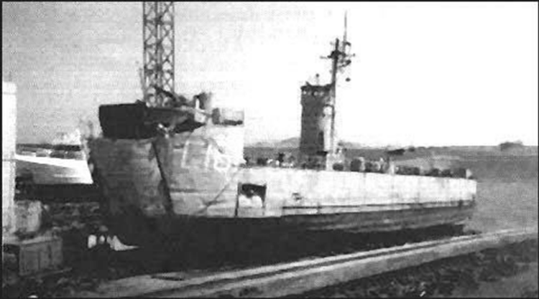LSM 45 Beached At the Shipyard

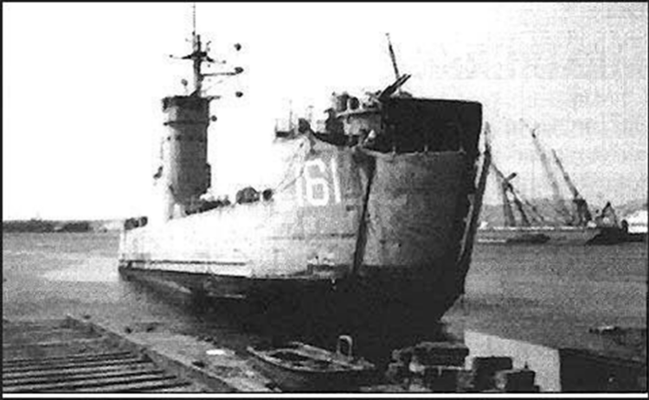On The Skids Before Work Performed

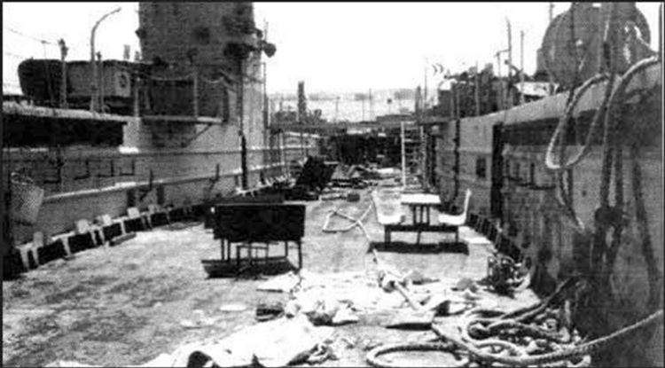Well Deck Before Work
Performed

After Repairs, Painting, And Mast Removed

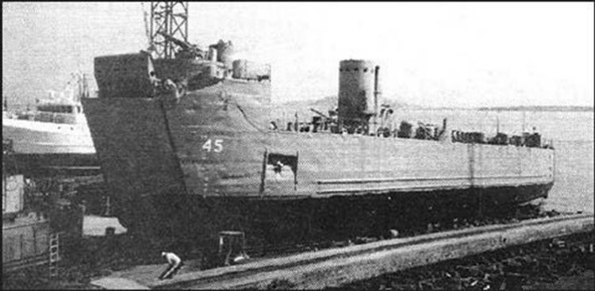The LSM 45 is now ready for the journey from
Greece
To Freedom Park, Omaha, Nebraska.

